

VOLTFLOW OS

Smart EV Charging Network Management Platform

A Comprehensive Specification on Real-Time Telemetry Pipelines, IoT State Engines, Smart Grid Peak Load Balancing, Reactive Maintenance Dispatch Workflows, and Production Scalability Architecture.

Prepared By: S.Venkata Subhash Reddy
Reg.no:192372195
CSA1012-Software Engineering
Guide : Dr.K.Anita Davaman
Date : July 20, 2026

INDEX

S. No. | Section / Topic | Page
1 | Contents and Assignment Overview | 2
2 | Problem Analysis and Project Objectives | 3
3 | Project Structure Design | 4
4 | Git Repository Initialization | 5
5 | Git Branching Strategy | 6
6 | Version Control Workflow | 7
7 | Commit History Analysis | 8
8 | Docker Environment Design | 9
9 | Dockerfile Development | 10
10 | Docker Compose Design | 11
11 | Container Deployment, Testing and Results | 12
12 | Benefits of Git and Docker | 13
13 | Challenges, Improvements and Final Validation | 14
14 | Final Summary and Rubric Mapping | 15

Git & Docker Technical Assignment

CONTENTS AND ASSIGNMENT OVERVIEW
Project: Smart Electric Vehicle Charging Network Management Platform | Technical focus: Git, Docker, collaboration and containerized deployment.
Section | Coverage
1. Problem Analysis | Domain, objectives, users, requirements and outcomes.
2. Project Structure | Repository tree, file roles and organization rules.
3. Git Initialization | Repository creation, essential files and baseline commit.
4. Branching Strategy | main, develop, feature, release and hotfix.
5. Version Control | Commit, merge, synchronization and conflict handling.
6. Commit History | Message standards, auditability and release traceability.
7. Docker Environment | Container roles, networking, storage and configuration.
8. Dockerfile | Image construction and security practices.
9. Docker Compose | Services, volumes, dependencies and network.
10. Deployment & Testing | Build, run, health, functional and recovery tests.
11. Benefits | Collaboration, portability, scalability and maintenance.
12. Challenges & Improvements | Risks, improvements, checklist and conclusion.

Assignment Context
The EV platform manages a distributed charging network. Git is used to control application and infrastructure changes; Docker is used to package the frontend, API, IoT worker, database and cache environment.

Assessment Evidence
- Source repository and commit history
- Branching evidence
- Dockerfile and Compose file
- Architecture/workflow diagrams
- Execution and test screenshots
- Final technical report
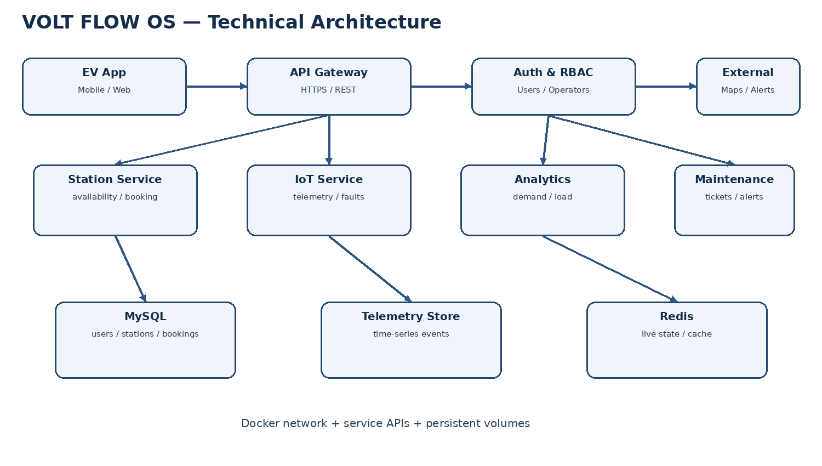

1. PROBLEM ANALYSIS AND PROJECT OBJECTIVES
The platform addresses charging-network problems: low charger utilization, waiting time, uneven electrical load, limited monitoring and late equipment-failure detection. It receives charger availability, charging status, energy use, reservations, station health and grid-load information.

Primary Objectives

Objective | Technical Support
Availability | Live charger state and station search.
Session Tracking | Session start, status, energy and completion.
Demand Prediction | Historical telemetry and reservation trends.
Charger Allocation | Assign suitable available charger.
Load Balancing | Observe station/grid load and apply limits.
Maintenance | Detect faults and create alerts.
Analytics | Operational dashboards and reports.
Scale | Support many stations and concurrent sessions.

Core Functional Requirements
- User registration/login and role control
- Station and charger search
- Reservation creation/cancellation
- Real-time session tracking
- Telemetry ingestion
- Station-health monitoring
- Demand forecasting
- Allocation and load optimization
- Maintenance alerts
- Reports and operational analytics

Expected Outcomes

Outcome | Measure
Lower waiting | Fewer queue/idle conflicts.
Higher utilization | More active use of available chargers.
Energy efficiency | Better load distribution.
Predictive maintenance | Earlier fault detection.
Lower cost | Fewer avoidable service events.
Scalable service | Independent service scaling.

Architecture Drivers
High availability, secure communication, low response time, continuous telemetry processing, recoverability, maintainability and independent scaling directly influence the Git/Docker design.

2. PROJECT STRUCTURE DESIGN
The repository uses clear separation of user interface, API, IoT processing, data, tests and infrastructure. This reduces coupling and makes changes easier to review.
Path | Role | Typical Contents
frontend/ | User interface | Pages, components, API client.
backend/ | Business/API layer | Routes, controllers, services, auth.
iot-service/ | Telemetry | Events, device status, fault processing.
database/ | Data definition | Schema, migrations, seed scripts.
tests/ | Verification | Unit, integration and API tests.
docs/ | Project knowledge | Architecture, setup, workflows.
Dockerfile | Image build | Base image, dependencies, startup.
docker-compose.yml | Environment | Services, ports, volumes, network.
.gitignore | Git hygiene | Logs, node_modules, secrets.
.dockerignore | Build hygiene | Git data, tests, local artifacts.
README.md | Onboarding | Prerequisites, commands, deployment.

Repository Tree
voltflow-os/
├── frontend/
├── backend/
├── iot-service/
├── database/
├── tests/
├── docs/
├── Dockerfile
├── docker-compose.yml
├── .gitignore
├── .dockerignore
└── README.md

Organization Rules
- One responsibility per folder
- Keep secrets outside repository
- Use environment variables
- Add tests with feature changes
- Document deployment changes
- Do not commit generated build folders

Why This Structure
A contributor can modify a feature without searching unrelated code. Docker configuration remains versioned with the source, while database and tests remain independently visible.

3. GIT REPOSITORY INITIALIZATION
Git records the complete evolution of source code and deployment configuration. Initialization creates the local repository; a remote repository supports collaboration and backup.

Initialization Steps
- Create the project folder.
- Run git init.
- Create README.md, .gitignore and .dockerignore.
- Add source folders and configuration.
- Review git status.
- Stage the baseline files.
- Create the first commit.
- Rename the primary branch to main.
- Add the remote repository.
- Push the initial branch.

Essential Files
File/Item | Purpose | Reason
.git/ | Git metadata/history | Version tracking.
.gitignore | Exclude local files | Avoid noise/secrets.
.dockerignore | Exclude build context | Smaller/faster builds.
README.md | Setup instructions | Faster onboarding.
Dockerfile | Image recipe | Repeatable runtime.
Compose file | Service stack | Repeatable environment.

Command Sequence
git init
git add .
git commit -m "chore: initialize EV charging platform"
git branch -M main
git remote add origin <repository-url>
git push -u origin main
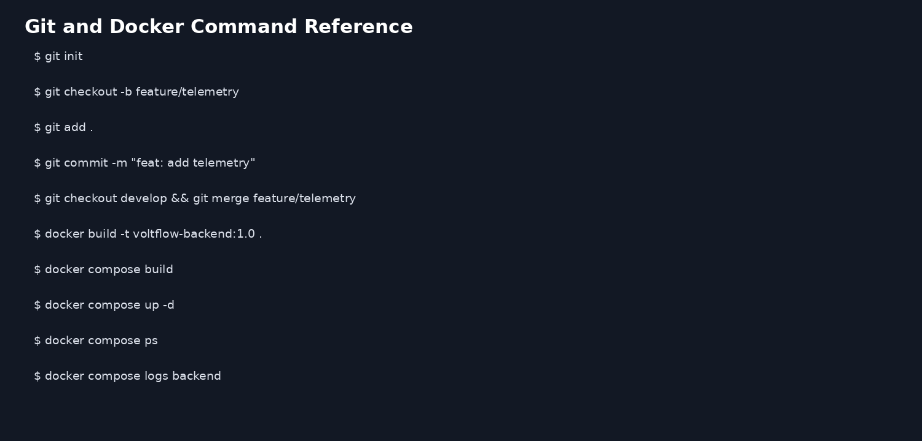

4. GIT BRANCHING STRATEGY
A Git Flow-style strategy provides controlled integration while allowing independent development of station, telemetry, reservation and analytics features.
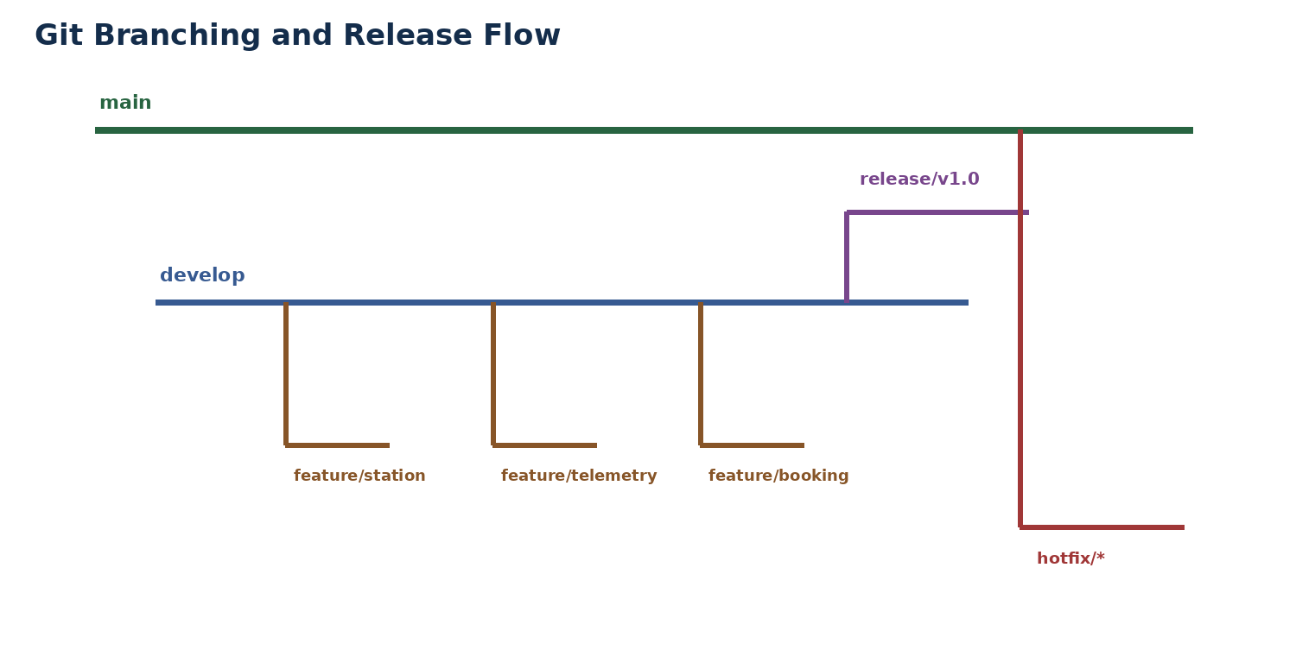
Branch | Rule | Example
main | Stable/release-ready | main
develop | Integration branch | develop
feature/* | One feature/change | feature/telemetry
release/* | Final testing | release/v1.0
hotfix/* | Urgent production fix | hotfix/api-timeout

Branch Lifecycle
feature/* → develop → release/* → main. Hotfixes branch from main, are tested, merged to main and synchronized back to develop.

Branch Protection
- Require review before main merge
- Run tests before release
- Use meaningful branch names
- Delete merged feature branches when appropriate
- Tag released versions
- Do not commit secrets

Why It Fits
The project has many independent modules and a distributed team workflow. Feature branches reduce interference; develop provides integration; release provides a controlled validation point.

5. VERSION CONTROL WORKFLOW
The workflow emphasizes small commits, frequent synchronization, review and tested merges. Every change should have a clear technical purpose.
Stage | Action | Output
1 | Create feature branch | Isolated work.
2 | Implement | Source/config changes.
3 | Test locally | Early defect detection.
4 | Stage | Selected files only.
5 | Commit | Traceable change.
6 | Push | Remote backup/review.
7 | Review | Quality check.
8 | Merge | Integrated feature.
9 | Release | Versioned stable code.

Common Operations
git status — inspect changes
git add . — stage files
git commit -m "..." — record change
git pull — synchronize
git push — publish
git merge feature/x — integrate
git log --oneline --graph — inspect history

Conflict Resolution
- Run merge.
- Inspect conflict markers.
- Decide the correct combined logic.
- Remove conflict markers.
- Run tests.
- Stage resolved files.
- Complete the merge commit.
- Push the verified result.

Good Practice
- Prefer one logical change per commit
- Avoid messages such as update/fix1
- Pull before starting major work
- Review changed files before commit
- Test after conflict resolution
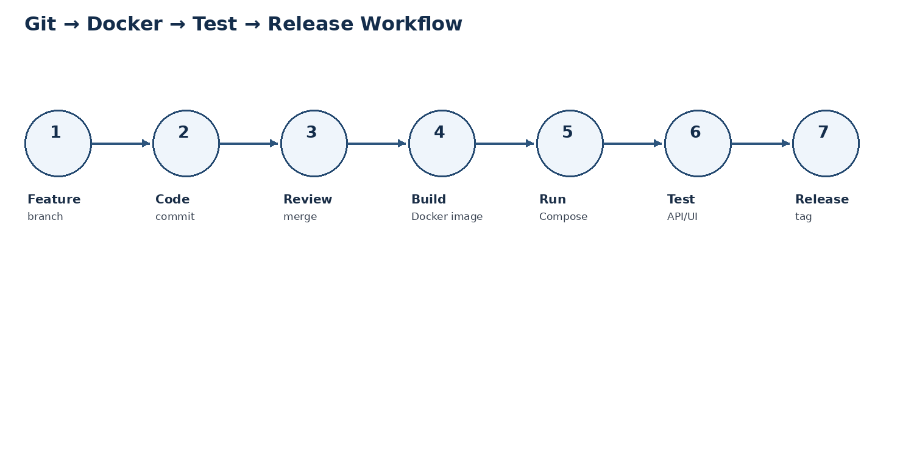

6. COMMIT HISTORY ANALYSIS
A readable history is useful for debugging, release preparation, audit and rollback. Commit messages should explain what changed and why.
Type | Example | Use
feat | feat: add charger availability API | New functionality.
fix | fix: handle duplicate reservation | Defect correction.
test | test: verify booking API | Verification.
docs | docs: update Docker setup | Documentation.
docker | docker: add backend healthcheck | Container change.
refactor | refactor: split telemetry handler | Internal improvement.

Illustrative History
a81f0d2 feat: add charger telemetry
7d22b18 feat: implement station search
c491e11 docker: add compose services
9be7d01 test: add reservation API tests
1f3a8cc chore: initialize repository

History Commands
git log --oneline
git log --graph --oneline --all
git show <commit>
git diff <commit1> <commit2>
git tag

Release Traceability
Artifact | Trace
Feature | Feature branch + commits
Integration | Merge commit / PR
Release | Release branch + tag
Deployment | Docker image tag
Rollback | Previous source tag/image
The sample history above is an expected format, not proof of execution. Final submission evidence should use the student's actual repository history.

7. DOCKER ENVIRONMENT DESIGN
Docker provides consistent execution for a multi-service EV platform. Each service has an isolated runtime, while a private network allows controlled communication.
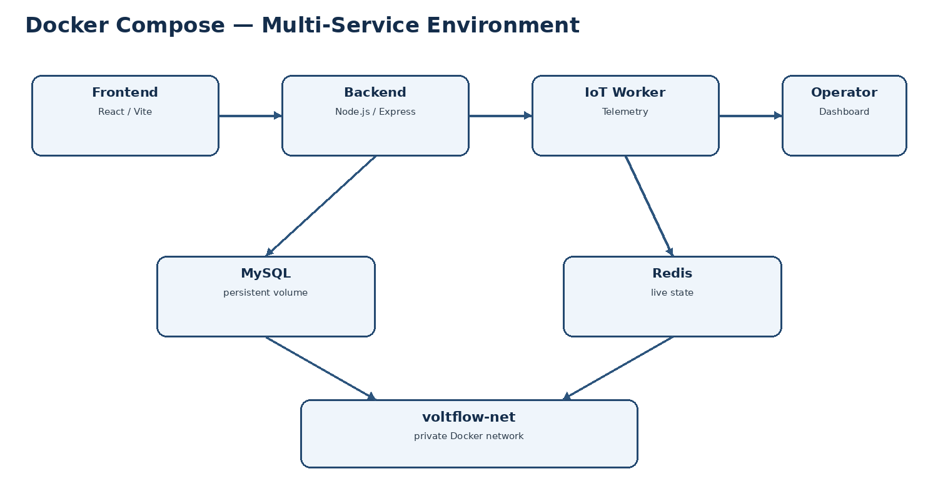
Service | Main Role | Data/Connection
frontend | User/operator interface | Calls backend API.
backend | REST API + business rules | MySQL + Redis.
iot-service | Telemetry/event processing | API + telemetry store.
mysql | Operational persistence | Users, stations, bookings.
redis | Fast current state | Live charger/session data.

Container Design
- Separate runtime responsibilities
- Expose only required host ports
- Use internal service names
- Persist database data with volumes
- Use environment variables for configuration
- Add health checks and restart policies

Networking
The voltflow-net Docker network provides service-to-service communication. In production, database and cache ports should remain private unless operational requirements explicitly require exposure.

Storage
MySQL data requires a persistent volume. Redis can be treated as a recoverable cache when live state can be rebuilt from durable sources.

8. DOCKERFILE DEVELOPMENT
The Dockerfile defines how an application component becomes a repeatable image. A Node.js backend is used as the representative service.

Representative Dockerfile
FROM node:20-alpine
WORKDIR /app
COPY package*.json ./
RUN npm ci --omit=dev
COPY . .
EXPOSE 5000
CMD ["node", "server.js"]
Instruction | Function | Benefit
FROM | Select Node runtime | Known base.
WORKDIR | Set application path | Predictable commands.
COPY package*.json | Copy dependency manifests | Layer caching.
RUN npm ci | Install exact dependencies | Repeatability.
COPY . . | Copy source | Build application.
EXPOSE | Document port | Operational clarity.
CMD | Start process | Consistent startup.

Build and Inspect
docker build -t voltflow-backend:1.0 .
docker images
docker run --rm -p 5000:5000 voltflow-backend:1.0

Security and Efficiency
- Use minimal trusted base images
- Run as non-root where supported
- Scan images for vulnerabilities
- Keep secrets out of Dockerfile
- Use .dockerignore
- Pin important dependency versions
- Prefer multi-stage builds for compiled frontends

Failure Handling
If a build fails, inspect dependency errors and Docker context. If a container exits, inspect docker logs and verify environment variables, ports and dependent services.

9. DOCKER COMPOSE DESIGN
Compose defines the local multi-container environment in one declarative file. It reduces manual startup steps and makes service dependencies visible.


Representative Compose Configuration
services:
frontend:
build: ./frontend
ports: ["3000:3000"]
depends_on: [backend]
backend:
build: ./backend
ports: ["5000:5000"]
depends_on: [mysql, redis]
iot-service:
build: ./iot-service
depends_on: [backend]
mysql:
image: mysql:8
volumes: [mysql_data:/var/lib/mysql]
redis:
image: redis:7
volumes:
mysql_data:
Element | Purpose
services | Defines runnable components.
build | Builds local application images.
ports | Maps required host/container ports.
depends_on | Express startup relationships.
volumes | Persists database state.
environment | Injects configuration safely.
network | Private service communication.

Useful Commands
docker compose build
docker compose up -d
docker compose ps
docker compose logs -f backend
docker compose restart backend
docker compose down

10. CONTAINER DEPLOYMENT, TESTING AND RESULTS
Deployment validation must prove that the images build, containers start, services communicate and core application functions operate correctly.

Test ID | Test | Expected Result
T01 | Compose build | All required images build.
T02 | Service start | Containers start without fatal errors.
T03 | Frontend | UI opens on configured port.
T04 | API health | Backend responds successfully.
T05 | Database | Application can read/write records.
T06 | Cache | Live state is stored/retrieved.
T07 | Telemetry | IoT worker processes events.
T08 | Reservation | Valid booking is stored.
T09 | Restart | Service recovers after restart.
T10 | Shutdown | Compose stops cleanly.

Verification Commands
docker compose ps
docker compose logs --tail=100 backend
docker compose logs --tail=100 iot-service
docker inspect <container>
docker stats

Expected Result
A successful run shows required containers active, healthy service communication, correct API/UI responses and persistent database records after a restart. Actual screenshots from Docker Desktop/terminal should be attached as evidence.

Operational Checks
- CPU and memory use
- Container restart count
- API response errors
- Database connectivity
- Telemetry processing status
- Network connectivity
- Log warnings

11. BENEFITS OF GIT AND DOCKER
Area | Git | Docker
Collaboration | Branches, reviews, merge history | Identical development environment
Versioning | Traceable source changes | Versioned build configuration
Portability | Clone repository | Run same service images
Deployment | Release tags | Repeatable container startup
Scalability | Parallel feature work | Independent service scaling
Maintenance | Audit and rollback | Isolated dependencies
Recovery | Revert known commit | Recreate known image
Consistency | Controlled configuration | Standard runtime

Combined Lifecycle
Requirement → feature branch → implementation → commit → review → merge → Docker build → Compose deployment → automated/manual tests → release tag → monitored operation.

Value for EV Charging Operations
- Faster delivery of station features
- Controlled telemetry-service changes
- Repeatable operator deployment
- Reduced environment mismatch
- Easier recovery from faulty releases
- Clear separation of application and infrastructure

Recommended CI/CD Extension
Pipeline Stage | Action
Source | Checkout tagged/approved commit.
Quality | Lint + unit tests.
Build | Create Docker images.
Security | Scan dependencies/images.
Integration | Start Compose test stack.
Release | Tag images and source.
Deploy | Promote approved version.
Monitor | Collect logs/metrics and alert.

Long-Term Maintainability
Standard Git practices plus containerized environments make onboarding easier and reduce configuration drift. Service boundaries also allow future migration from Compose to a larger orchestration platform when scale requires it.

12. CHALLENGES, IMPROVEMENTS AND FINAL VALIDATION

Challenges
Challenge | Impact | Mitigation
Telemetry volume | CPU/memory growth | Queueing, batching, worker scaling.
Network interruption | Lost device events | Retry, buffering, timestamps.
Startup order | Temporary connection failure | Health checks and retry logic.
Secrets | Security exposure | Environment/secret manager.
Merge conflicts | Integration delay | Small commits + review.
Large images | Slow builds | Minimal/multi-stage images.
Data persistence | Loss after restart | Named database volumes.
Monitoring gap | Late fault detection | Logs, metrics, alerts.

Improvements
- Automated CI/CD
- Image vulnerability scanning
- Container health checks
- Centralized logs
- Metrics and alerting
- Database migrations
- Automated rollback
- Independent telemetry-worker scaling
- Production secret management

Requirement-to-Evidence Validation
Requirement | Evidence
Repository control | Git init, commits, branches, history.
Containerization | Dockerfile and image build.
Multi-service deployment | Compose configuration.
Portability | Repeatable container startup.
Testing | Deployment/test matrix.
Maintainability | Repository structure and documentation.
Future scalability | Service separation and worker model.

Final Submission Checklist
- Git repository URL / local repository
- Complete commit history
- Branch evidence
- Source code
- Dockerfile
- docker-compose.yml
- Git screenshots
- Docker execution screenshots
- Architecture diagram
- Testing evidence
- Challenges and future enhancements
- Final report ≤ 15 pages

Conclusion
The proposed Git and Docker approach supports a disciplined development and deployment process for the Smart EV Charging Network. Git provides collaboration, traceability and controlled releases; Docker provides repeatable service environments. Together they improve portability, maintainability, testing and future scalability.

FINAL SUMMARY AND RUBRIC MAPPING

Technical Summary
Component | Selected Approach | Reason
Version Control | Git + Git Flow-style branches | Parallel work + controlled releases.
Application Runtime | Docker containers | Portable and repeatable runtime.
Local Orchestration | Docker Compose | Simple multi-service deployment.
Persistence | MySQL volume | Durable operational data.
Fast State | Redis | Low-latency live status.
Telemetry | Dedicated IoT worker | Independent event processing.
Testing | API/UI + container tests | Functional and deployment confidence.

Rubric Mapping
Criteria | Report Evidence | Target
Problem Analysis & Project Design | Pages 3–4 | Excellent
Git Repository & Branching | Pages 5–6 | Excellent
Version Control & Commit History | Pages 7–8 | Excellent
Docker Implementation | Pages 9–11 | Excellent
Deployment, Testing & Results | Page 12 | Excellent
Documentation & Future Work | Pages 13–15 | Excellent

Student Completion Items
- Replace illustrative Git history with actual git log screenshot.
- Add actual GitHub/GitLab repository screenshot.
- Add actual Docker Desktop/terminal screenshot.
- Add running application screenshot.
- Confirm Dockerfile and Compose file match submitted source.
- Verify report remains within 15 pages after screenshots are inserted.

Final Result
The report provides a complete Git & Docker technical assignment for the Smart Electric Vehicle Charging Network Management Platform, with compact explanations, high-information tables, diagrams, commands, testing criteria and assessment mapping.

